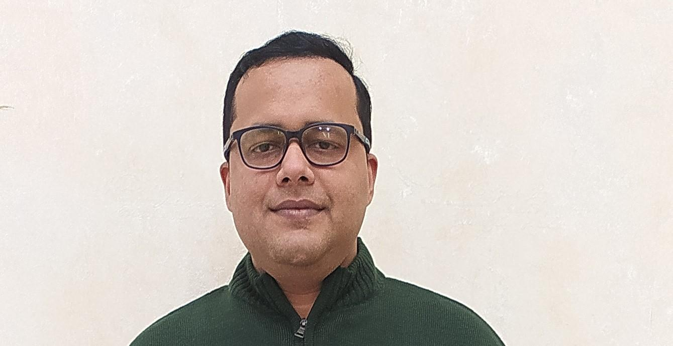

**ANUSTUP GANGOPADHYAY** **Email** : [***anustup11@gmail.com***](mailto:anustup11@gmail.com)

**Mobile**: +91 7890099909, 8209028986

**CAREER OBJECTIVE:-**

To utilize my strong functional and technical background in ERP, Cloud, SAP and Success Factors HXM in Project/Product Management, and Operations Management areas to assist companies in ERP, HRIS, HR Shared Services and Delivery Management.

**PROFILE “what can it translate to”**

* Competent Senior Consultant with diverse experience implementing and managing HR Shared Services and support in Configuration of HRIS, Cloud HCM,SAP, Success factors PMGM, Employee Central, Succession Planning, Learning management systems, Success factors other modules, SAP and ERP Cloud HCM.
* Experienced in Project/Product Management and Delivery Manager Role for Cloud HCM, SAP HCM & Success factors.
* Forecasting financial and operational performance metrics, Scoping & Budgeting, Project Charter, including cloud renewal rates, sales productivity, operating profit, and provide LoB leadership with insight into sales forecast/sales KPIs, Annual Contract Value Bookings for SAP ECC Functional Modules, S4 HANA & Success factors.
* Ensuring HR service delivery is compliant with the standards, SLAs and KPIs and friction-free
* Managing teams and/or work efforts (if in an individual contributor role) at a client or within Project Team Orientation & Train the user communities (End users / Super Users).
* Continuously support and develop Peers and Analysts and employee self-reliance, and work with Corporate HR teams through continuous improvement mechanisms to automate and optimize processes.
* Develop and maintain the capability to cover colleagues in the Operations Specialist team through knowledge and support of another area of My HR (Success Factors) and related processes eg Recruiting, Employee Central, Onboarding.
* **TECHNICAL SKILLS**: ERP, SAP ECC EHP8, SAP S4 HANA 1909, Success factors, ERP,HONO AI, JIRA, Cloud HCM, HRIS.

**WORK EXPERIENCE:-**

**Senior Consultant HCM – Nihira Business Solutions India pvt ltd,** (Jan 2014 – Till Date).

**Roles & Responsibilities:**

* Ensuring delivery of efficient and highly customer focused HR transactional and administrative service.
* Leading the implementation of Cloud HCM, SAP HCM, Success factors, Employee Central, Performance & Goals, and Learning Management in projects for Financial Services, Hospitality and Manufacturing sectors.
* Responsible for developing a strategy for the service to achieve excellence through continuous improvement for services and able to articulate change, process improvement to HR team members and business customers.
* Provide leadership to junior systems analysts and client personnel assigned to projects to enable them to complete their assigned activities accurately and by the due dates. As a result the junior systems analysts are able to work independently in their next project.
* Ensuring that the HR data and administrative services follow standardized process and policy efficiently and effectively to meet business requirements and SLAs, optimizing and continuously simplifying the service user interface.
* Interact with customer business SME’s, Project Managers and Users at different stages of engagement and to test the prototype developed for Success factors , resulting in a smooth deployment with minor issues to be resolved following go live.
* Manage escalation points/helpdesk for the end customer to escalate issues and continuously support and develop Peers and Analysts and employee self-reliance, and work with Corporate HR teams through continuous improvement mechanisms to automate and optimize processes.
* Maintain and improve performance on KPIs to ensure continuous improvement of service and data quality.
* Retaining resources through continuous development opportunity for individuals and teams in meeting these objectives through high levels of engagement and stretch goals.
* Responsible for conducting where necessary the recruitment, training, standardization and performance evaluation of executives and team leaders.
* Experienced in Configuration of SAP HCM – OM, PA, Time Mgmt & Payroll and configuring and administering ESS/MSS and PCR (Personnel change request) Management, Organizational Management (OM) and Personnel Administration modules.HR testing experience – Integration Testing, Unit Testing, Parallel Testing, User Acceptance Testing, writing Test cases and used eCATT for testing external tools.
* User access through role-based permissions in Success factors modules, Foundational Objects Configuration, Configured Self Service (MSS / ESS) Transactions, Workflow Configuration, EC Position Management, EC Timesheets.
* Configuring Time off, Proxy management, Import and Export Data, Configure Object Definitions, Holiday Calendars, Work Schedules, Scales, Route Maps, Performance Management & Goal Management, Template Management, 360 Review and Calibration, Form Settings, for Iteration 1, 2 and 3, testing and deployment.
* Conduct knowledge transfer and training of end-users, including sharing best practices – Prepared KT & training presentation used to train end-users. Trained 5 -10 users in sessions and received an average rating of 8/10 for the training.
* Configuring solution requirements on the products; understand if any issues, diagnose the root-cause of such issues, seek clarifications, and then identify and shortlist solution alternatives.
* Understanding requirements, develop detailed requirements, develop a business case, and develop Functional requirements.
* **Current Projects**: - Apollo Munich, Volvo Cars, Spencer’s, Nature’s Basket, Agile Indigo Airlines.

**Oct, 2012 – Nov 2013 | Senior Practioner - State Street Corporation (US) | IBM (India)**

**Roles & Responsibilities:**

* Worked as SME - Senior Specialist in ITSM Service Desk Management, leading team of 20 resolving and managing the Ticket Volume, Ticket Distribution, Response Time Management and SAP End-user Support.
* Plan work schedules for global help desk operations and assign staff to accomplish daily work by providing for variations in workload.
* Active involvement in employee development through training, coaching and performance management.
* Manages the overall Service Desk performance for the region of responsibility as well as the performance of individual Team Leads and Analysts.
* Monitors and measures the performance and results of IT Service Desk resources and provides direct and timely performance feedback.
* Provide superior communications to management, business partners and other stakeholders regarding IS performance.
* Review, assign, reconcile and support the management of tickets throughout their lifecycle.
* Monitor and support ticket workflows.
* Helps coordinate with IT service providers and communicates outages and plans for recovery.
* Install and provide desktop support for Windows Operating System, Microsoft Office and Adobe software.

**Jun, 2009 – Feb 2012 | Associate Consultant - Astrol Info Technologies, Noida (India )**

**Roles & Responsibilities:**

* Work within the team framework created by management and collaborate work with team members on assigned projects.
* Assist in maintaining software and workstation image management, including the use of image deployment software to perform imaging tasks for workstations.
* Provide assistance by phone, GoTo Assist, in person, and using the Manage Engine ticket system.
* Assist in providing support to project managers to integrate and transition projects or new technology efforts to the production support environment.
* Assist with management of IT resources including workstations, laptops, projectors and their inventory.
* Assist Manager (or other supervisor as assigned) with project management and execution.
* Operates personal computer terminals and LAN attached to workstations to perform job function and general clerical/administrative work.

**Aug, 2007 – Dec 2008 | Process Associate – Dell (US) | Wipro (India)**

**Roles & Responsibilities:**

* Reporting and troubleshooting issues in Service Desk and Incident Management Systems, BMC REMEDY and maintaining high level of Customer service and adhering to customer service parameters and Troubleshooting issues for Dell Laptops and Technical Support and Troubleshooting issues with Remote Access.
* Worked and agreed on new auto ticketing rules to be applied based on current rules, polling classes and input from Operations teams and Liaise with Level 3 teams to complete configuration of new Event Management systems.

**EDUCATIONAL QUALIFICATION:-**

* Executive Masters in Business Administration from Indian School of Business Management & Administration, New Delhi.
* Bachelors in Science from International Institute of Hotel Management and Tourism (MIGMT), Kolkata.
* Senior Secondary: From CBSE, Bharti Public School, New Delhi.
* Secondary: From CBSE, D.A.V. Model School, Durgapur.

**ACHIEVEMENTS:-**

* Awarded Best Performer out of 215 employees during the period of employment and Customer, client Satisfaction Award on recommendation by the Client at Teamone Software Technologies 2017-2018.
* Awarded highly commendable merit certificate in Essay Contest & Quiz Contest Bournvita, India Organized by Bharti Public School, New Delhi and represented as a Young Reporter for Times of India “Newspaper in Education” for the Academic Session 2002-03.
* Participated in “Adventure Course” Organized by THE HIMALAYAN HIKERS, Durgapur, and WEST BENGAL in 1997 & has won highly commendable merit certificate.

**LEISURE PURSUIT & HOBBIES:-**

* Road trips, travelling, Wildlife photography, cooking, music, reading books and Voluntary and Social Service activities with non-governmental organizations.

**PERSONAL DETAILS:-**

Father’s Name : CHANDAN KUMAR GANGOPADHYAY

Languages Known : English, Hindi, Bengali

Date of Birth : 9th December, 1985

Nationality : Indian

**PLACE: DATE: (Anustup Gangopadhyay)**